Online Shopping system- web application
User login test cases

Module Name: Online shopping system-user login test cases(Web)
Test case ID: TC001
Platform: Web application(Responsive)
Login Method: username + password

Home page

Scenario ID: 1
Scenario: login with valid credentials
Test steps:
- Enter valid username :standard_user
- Enter valid password:secret_sauce
- Click on login

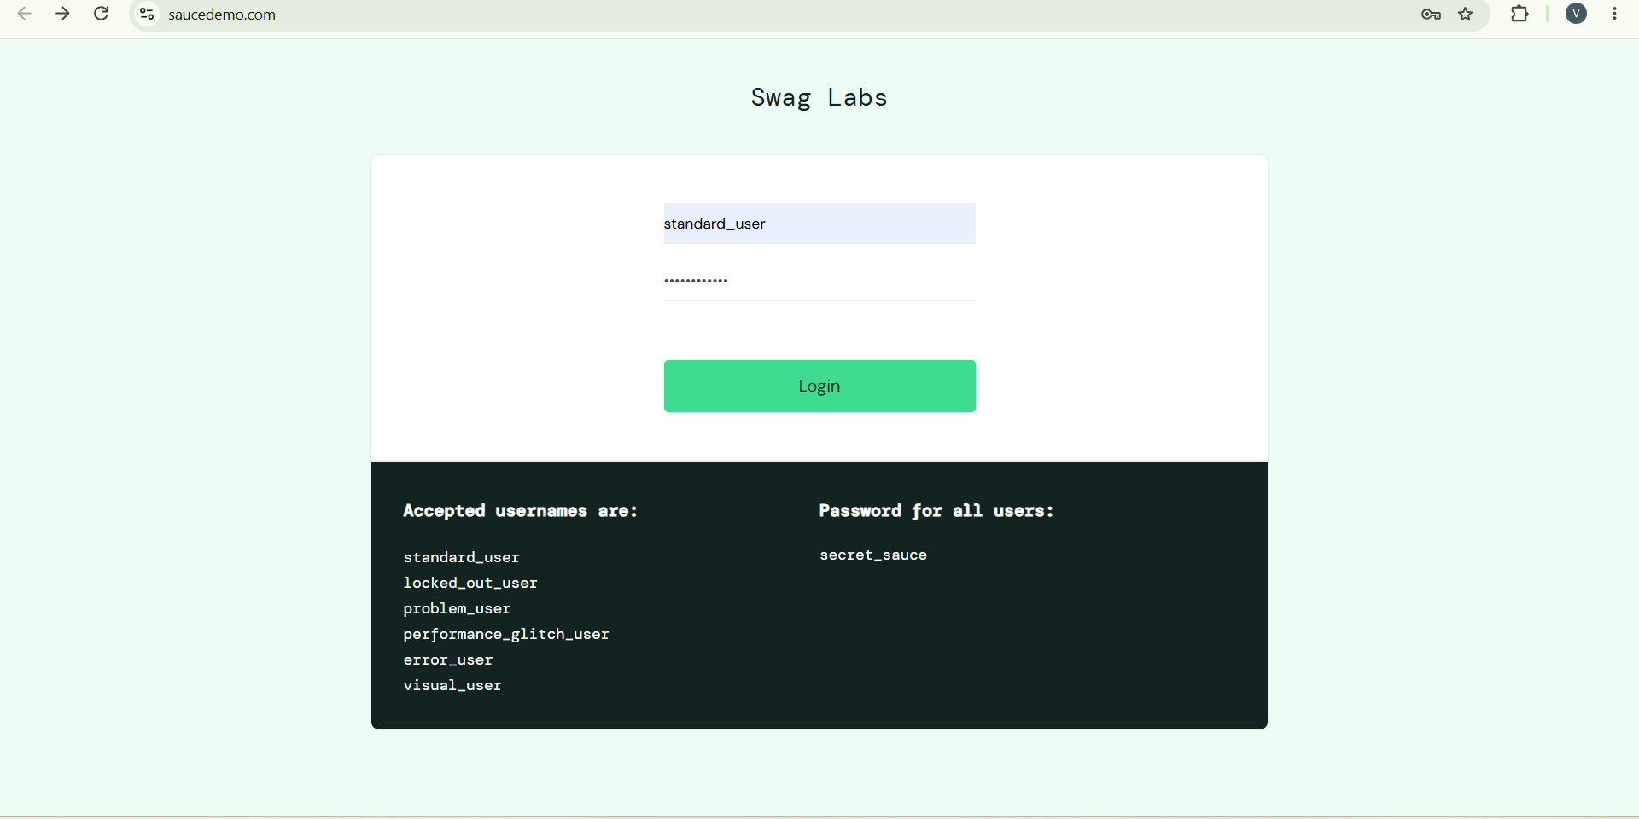

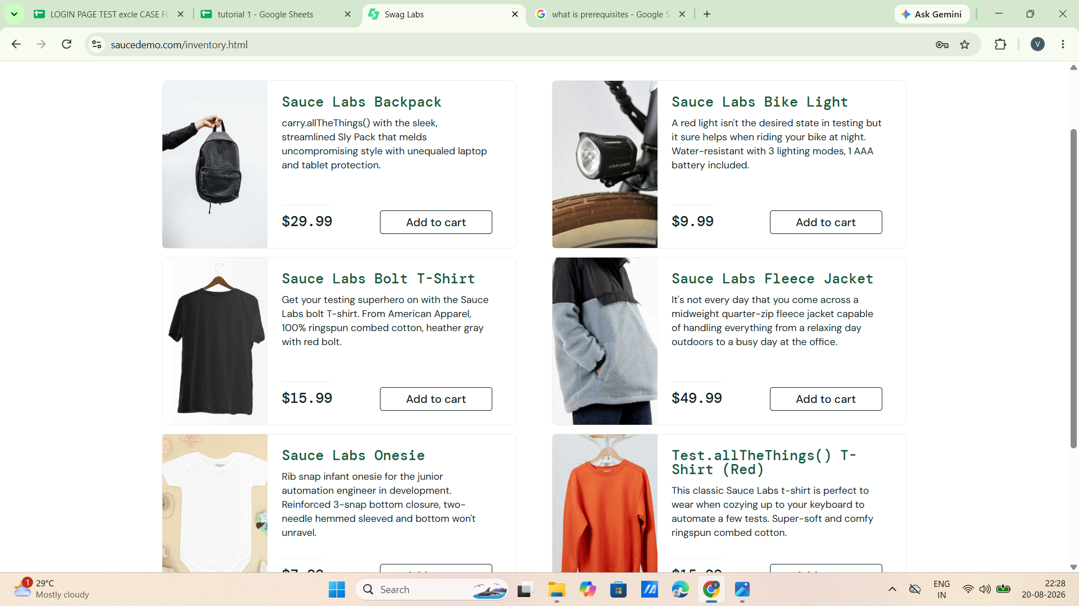

Scenario ID: 2
Scenario: login with invalid username
Test steps:
- Enter invalid username: vidhi patel
- Enter valid password: secret_sauce
- Click on login

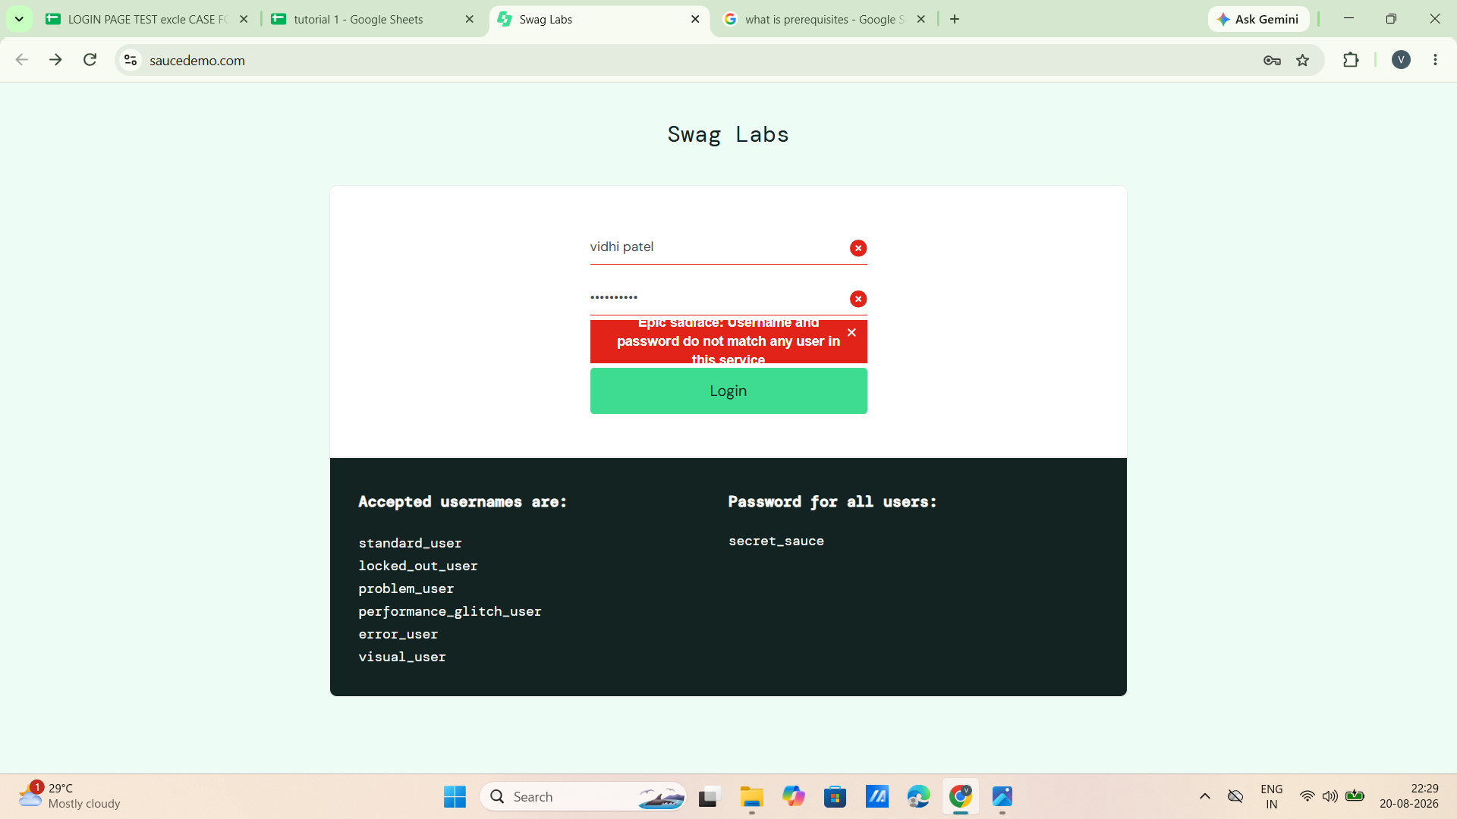

Scenario ID: 3
Scenario: login with invalid password
Test steps:
- Enter valid username : standard_user
- Enter invalid password : Godisgreat
- Click on login

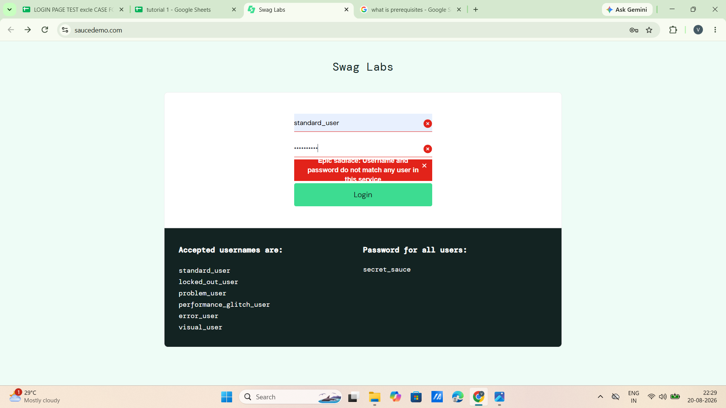

Scenario ID: 4
Scenario :login with invalid password and invalid username
Test steps:
- Enter invalid username:vidhi patel
- Enter invalid password: Godisgreat
- Click on login

Scenario ID: 5
Scenario: login with empty username
Test steps:
- leave black at username: -
- Enter valid password: secret_sauce
- Click on login

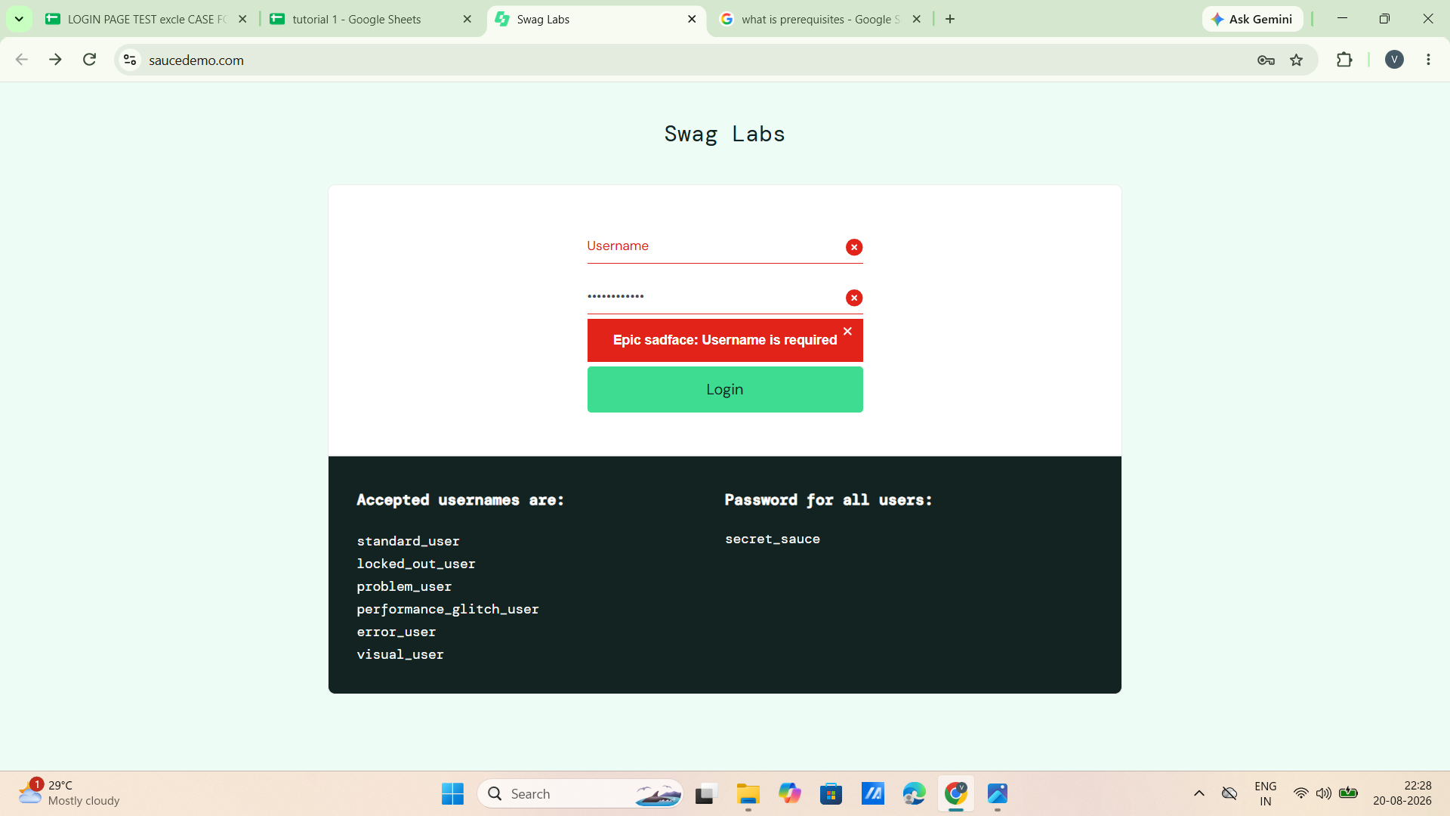

Scenario ID: 6
Scenario: login with empty password
Test case:
- login with valid username: standard_user
- leave blank at password: -
- Click on login

